Palash Bajpai

URL ShortENER

Design URL Shortener

A URL shortener is a service that converts a long URL into a shorter, unique version that redirects to the original link.
It's useful for sharing links easily, especially on platforms with character limits or for tracking link analytics.

1. Questions to ask

- What if the same long URL is submitted multiple times?
- Should the same long URL always map to the same short URL?
- Do we need to save shortened URL, and is there concept of who owns the shortened url.

Think out loud:
- Should we cache hot URLs? (performance )
- What if short code already exists? (performance)
- How to avoid malicious URLs? (security)
- Do we allow expiration? (security)
- What bottlenecks could arise with a single DB? (scalability)
- How to shard or partition the DB? (scalability)

2. Core Flow

- Client sends long URL to /shorten
- Server:
  - Generates a unique short code (via Base62 hash or ID-based encoding)
  - Stores mapping in DB
- When user hits GET /{shortCode}:
  - System fetches long URL from DB (or cache)
  - Redirects via HTTP 302/301

Key concepts used:
- Hashing / Base62 encoding for generating short URLs
- Database for storing mappings
- Caching (Optional) like Redis for frequent URLs
- HTTP API with REST endpoints
- Unique ID generation (auto-incremented, UUID, etc.)

3. Required API’s

Endpoint | Method | Description
/shorten | POST | Accepts long URL and returns a shortened URL
/{shortUrl} | GET | Redirects to the original long URL
/shorten/{shortUrl} | GET | (Optional) Returns original long URL as JSON
/delete/{shortUrl} | DELETE | (Optional) Deletes a short URL
/analytics/{shortUrl} | GET | (Optional) View click stats

4. Database setup

Field | Type | Description
id | BIGINT (PK) | Auto-incremented ID
short_code | VARCHAR(10) | Unique short code (Base62)
long_url | TEXT | Original URL
created_at | TIMESTAMP | When created
expiration | TIMESTAMP | Optional expiration time
clicks | INT | (Optional) Number of redirects

You can index short_code and long_url for quick lookup.

Which DB to use:
- Use MySQL/PostgreSQL as the primary database because they offer reliable data storage, auto-increment IDs for short URL generation, and support indexing for fast lookups.
- Add Redis as a cache layer to speed up frequently accessed short URLs.
This combo gives you both data durability and high performance for production.
Why SQL over NoSQL:
- Auto-incremented IDs in SQL are perfect for generating unique short codes using Base62 encoding.
- SQL databases offer strong consistency, ensuring reliable mapping between short and long URLs.
- Unique constraints help prevent duplicate short codes or long URLs.
- SQL supports analytics and reporting with complex queries (e.g., top URLs, expiry).
- It's easier to maintain and scale with read replicas and mature tooling in production.

For start, do partitioning and later if need to horizontally scale, do sharding.
- Use partitioning for better query performance;
- Use sharding when a single database can't handle the load.

5. Final Design

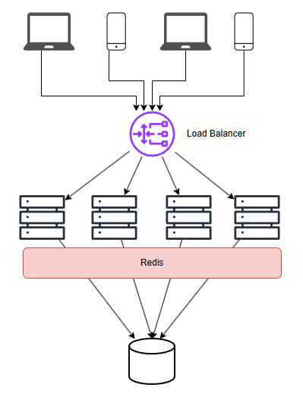
Can use CDN if required to scale globally

6. Miscellaneous

1. Partitioning and Sharding Strategy
- Start with SQL + partitioning for simplicity.
- At scale, use sharding by hash(short_code) to distribute load.
- Add a routing layer in your app or use tools like ProxySQL or Vitess to manage sharded SQL databases.

1. Partitioning (within a single SQL DB)
Best column: id or created_at
Why?
- id is sequential → good for range partitioning
- created_at → allows time-based partitioning for easy archival or purging of old URLs
Use this when the table grows too large (e.g., millions of URLs), to keep queries fast.

2. Sharding (across multiple DBs)
Best key: short_code or hash(id) or user_id (if user-specific URLs)
Why?
- short_code is used for lookups → ensures even distribution when hashed
- user_id if you're supporting users → helps group their URLs together
- hash(id) is deterministic and evenly distributes writes/reads across shards
Use this when read/write throughput exceeds single DB capacity.

2. Sample code for Encoding

package util;

public class Base62Encoder {
private static final String BASE62 = "0123456789abcdefghijklmnopqrstuvwxyzABCDEFGHIJKLMNOPQRSTUVWXYZ";

public static String encode(long value) {
StringBuilder sb = new StringBuilder();
while (value > 0) {
sb.append(BASE62.charAt((int)(value % 62)));
value /= 62;
}
return sb.reverse().toString();
}
}

3. Which redirects to use (301 or 302)
Use 302 Redirect (Temporary) in a URL shortener by default.

Redirect Type | Meaning | Browser/SEO Behavior | Use in URL Shortener?
301 | Permanent redirect | Caches the redirect; search engines transfer link juice | ❌ Not ideal (hard to update later)
302 | Temporary redirect | Doesn’t cache; allows updates to destination URL | ✅ Recommended

Why 302 is better for a URL shortener:
- You may want to change the target URL later (e.g. for analytics, fixes, campaigns).
- It avoids browsers and search engines caching the redirect permanently.
- More flexibility in managing URL destinations dynamically.

